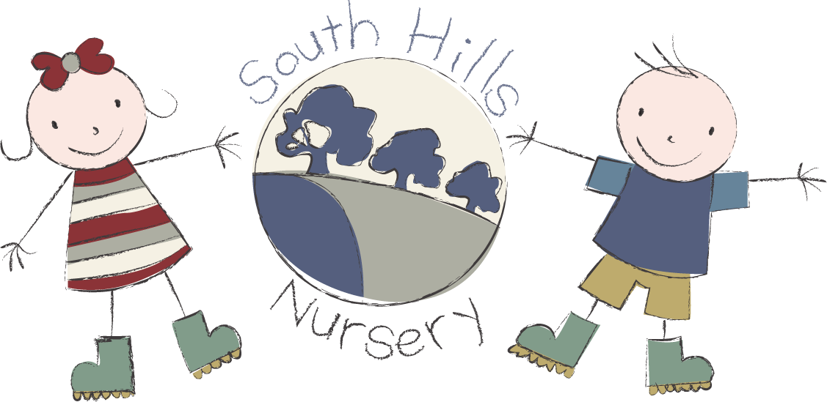
South Hills School Corsham
fees list 2026.

Terms available: 38 weeks or 51 weeks
Opening hours: 8.00am - 6.00pm

0–2-year-olds: Hourly rate £8.00 - meals included

2-year-olds: Hourly rate £7.80

3-year-olds: Hourly rate £7.40

Snacks: charged at 50p per half day

Breakfast: charged at 0.70p (if the child attends from 8.00am)

Hot lunch: charged @ £3.20 per meal.

Tea: charged @ £2.50 per meal. (if child stays after 16:00pm)

Funding:
2 Year funding is available to all eligible children.

3 Year funding is available to all children in the term after their third birthday.

Working Parent Entitlement is available to all eligible children the term after they turn nine months old on a 51-week basis and between the hours of 9.00am & 3.00pm.

Registration fee: £30 Non-refundable and payable on application.

Please contact our admin team for any further information on
01722 744971 EX 3.

