Breathing and calming resources
https://childhood101.com/take-5-breathing-exercise/
https://www.youtube.com/watch?v=sh79w9pn9Cg
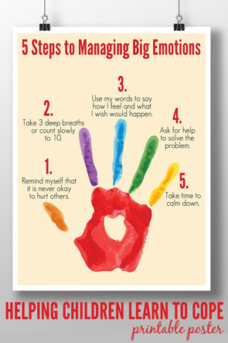
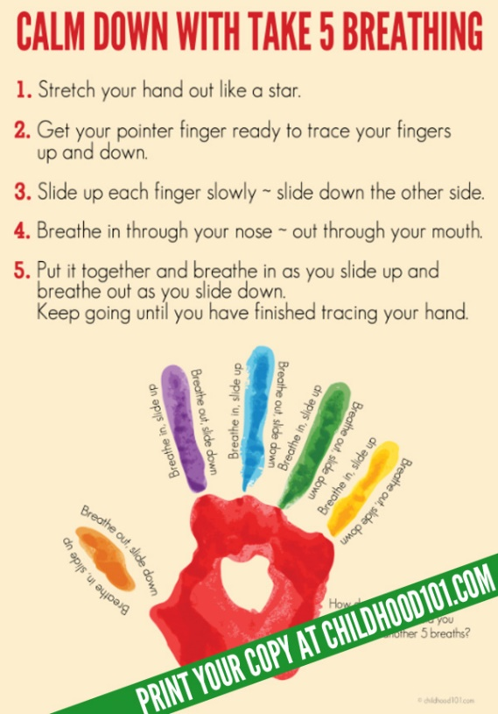

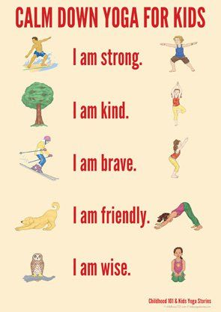

Breathing visualisation
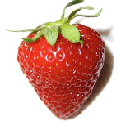
Think about smelling a strawberry – pretend to hold a strawberry up to your nose and breathe in as if you are smelling it.

Pretend to hold a candle in front of you, perhaps hold up a finger and pretend to blow it out slowly. Repeat 3 times or more if needed.

Sesame Street belly Breathe video
https://www.pbslearningmedia.org/resource/sesame-belly-breathe/belly-breathe-sesame-street/?#.WoInr0x2vIV
10 calm down activities for kids
https://theimaginationtree.com/10-calm-down-activities-for-kids/

