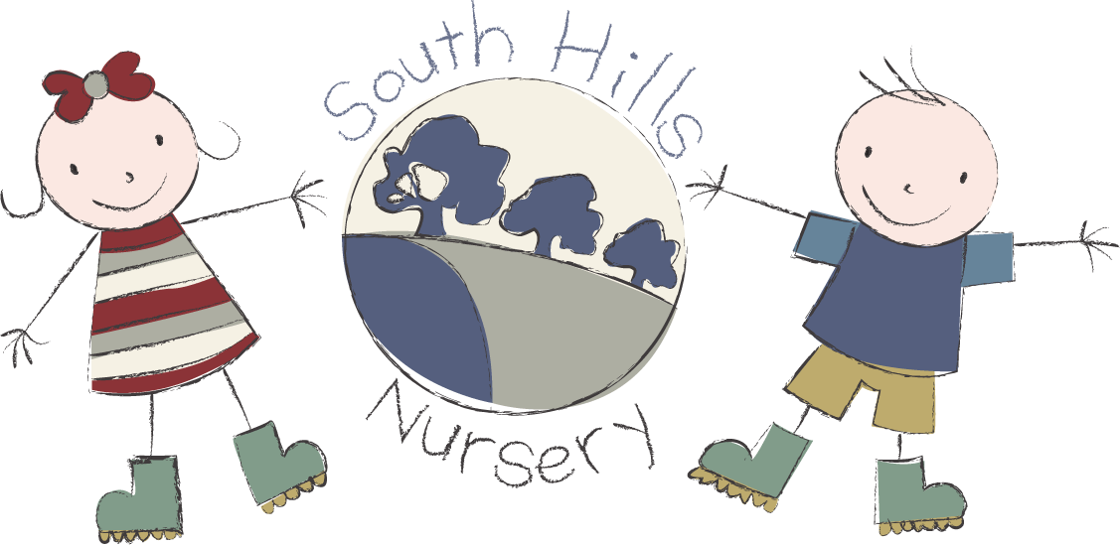
South Hills School City
fees list 2026.

Terms available: 38 weeks or 51 weeks
Opening hours: 8.00am - 5.00pm

0–2-year-olds: Hourly rate £8.00 - no snack fee

2-year-olds: Hourly rate £7.80

3-year-olds: Hourly rate £7.20

Snacks charged at 50p per half day

Hot lunch: This is available @ £3.20 per meal.

Tea: This is available @ £2.50 per meal.

Funding:
2 Year funding is available to all eligible children.

3 Year funding is available to all children in the term after their third birthday.

Working Parent entitlement available to children the term after they turn nine months old, between 9.00 – 15.00

Registration fee: £30 Non-refundable and payable on application.

Please contact our admin team for any further information on
01722 744971 EX 3.

