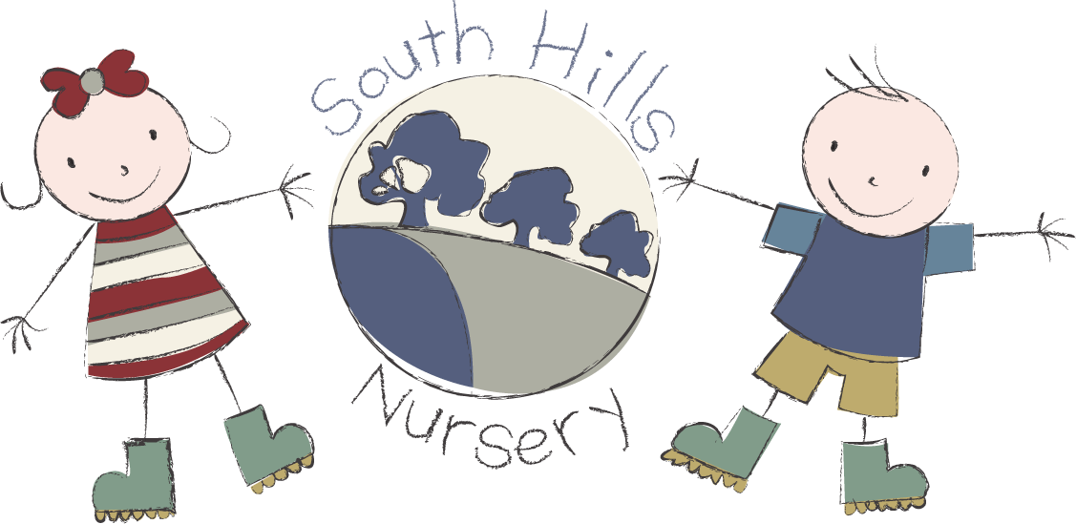
South Hills School Burcombe
fees list 2026.

Terms available: 38 weeks
Opening hours: 9.00am - 3.00pm

2-year-olds: Hourly rate from 9.00am–3.00pm £8.00

3-year-olds: Hourly rate from 9.00am-3.00pm £7.40

Snacks: Charged at 50p per half day

Funding:
2 Year funding is available to all eligible children.

3 Year funding is available to all children in the term after their third birthday.

30-hour funding is available to all eligible children the term after they turn nine months old.

Registration fee: £30 Non-refundable and payable on application.

Please contact our admin team for any further information on
01722 744971 EX 3.

