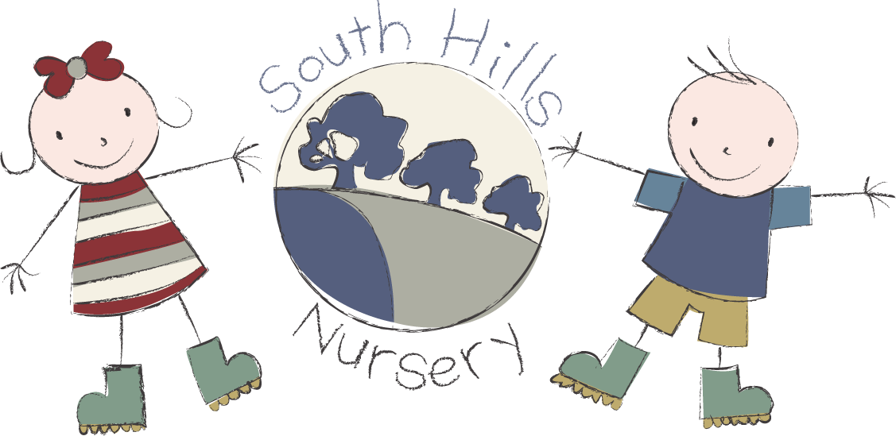
South Hills School Rowde
fees list 2026.

Terms available: 38 weeks or 51 weeks
Opening hours: 7.45am - 17.45pm

FEES:
8.30 – 9.00 Early start £5.00
9.00 – 15.00 £7.30 PER HOUR FOR 2’S
9.00 – 15.00 £6.70 PER HOUR FOR 3’S
15.00 – 15.30 Late finish £5.00
Snacks charged @ 50p per half day

Registration fee: £30 Non-refundable and payable on application.

FUNDING
2 Year Funding available to eligible children
3 Year funding available to all children in the term after their 3rd birthday.
Working Parent Entitlement on a 51-week basis only and between the hours of 9.00am & 3.00pm.

Please contact our admin team for any further information on
01722 744971 EX 3.

