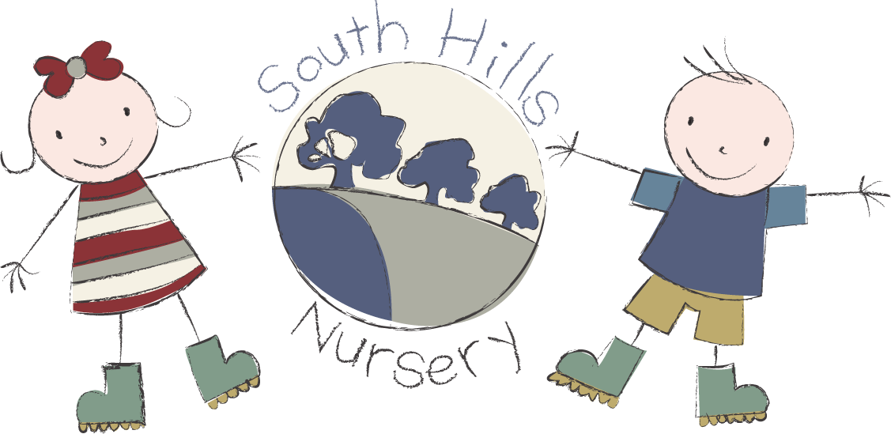
SOUTH HILLS SCHOOL STEPPING STONES

TERMS AVAILABLE 38 OR 51 WEEKS
OPENING HOURS 7.45 – 18.00

FEES:
7.45 - 18.00 £69.00
Hourly rate of £8.00 for all other sessions
Tea charged to all those staying after 16.00 @ £2.50
Hot Lunch available £3.50

When children join upper class the following charges apply.
7.45 - 18.00 Daily Charge £10.00
9.00 - 12.30 Daily Charge £7.50
9.00 - 15.00 Daily Charge £7.50
This is to cover the extra activities enjoyed by the children in Upper Class such as French, Tennis, Funky Dance, Cooking and Forest School.

FUNDING
2 Year Funding available to eligible children
3 Year funding available to all children in the term after their 3rd birthday.
Working Parent entitlement available on a 51 contract between 9.00 – 15.00

Registration fee: £35 Non-refundable and payable on application.

Please contact our admin team for any further information on
01722 744971 EX 3.

