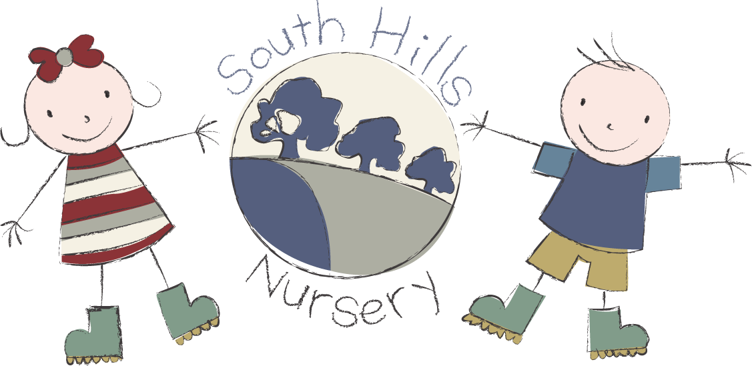
South Hills School City
fees list 2026.

Terms available: 38 weeks
Opening hours: 9.00am - 3.00pm

Flate fee: £6.90 Hourly rate

Funding:
2 Year funding is available to all eligible children.

3 Year funding is available to all children in the term after their third birthday.

Working parent entitlement available

Please contact our admin team for any further information on
01722 744971 EX 3.

