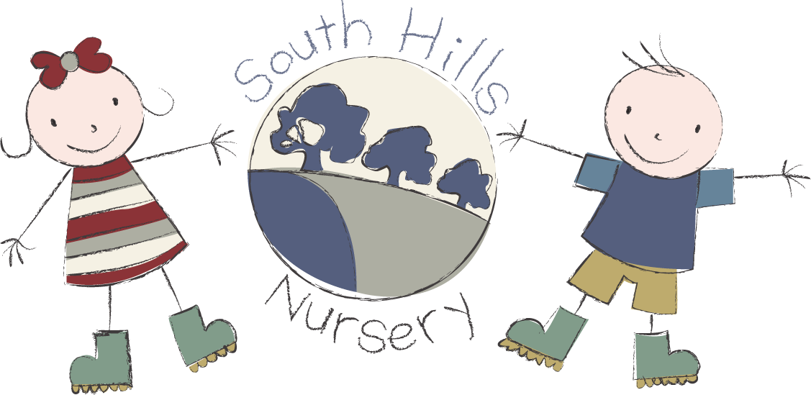

South Hills School St. Peter’s
fees list 2026.

TERMS AVAILABLE 38 OR 51 WEEKS
OPENING HOURS 7.30 – 18.00

FEES:
2’s £7.80ph between 9.00 – 15.00 OOS @ £5.00 per half hour
3’s £7.20ph between 9.00 – 15.00 OOS @ £5.00 per half hour
Sessions: 8.00 – 13.00
9.00 – 15.00
13.00 – 18.00
8.00 – 18.00
Breakfast: 0.70p
Hot Lunch available: @ £3.20 per meal.
Tea available: @ £2.50 per meal
Snacks charged: @ 50p per half day

FUNDING:
2 Year Funding available to eligible children
3 Year funding available to all children in the term after their 3rd birthday
Working Parent Entitlement on a 51 week basis only and between 9.00 – 15.00.

Registration fee: £30 Non-refundable and payable on application.

Please contact our admin team for any further information on
01722 744971 EX 3.

